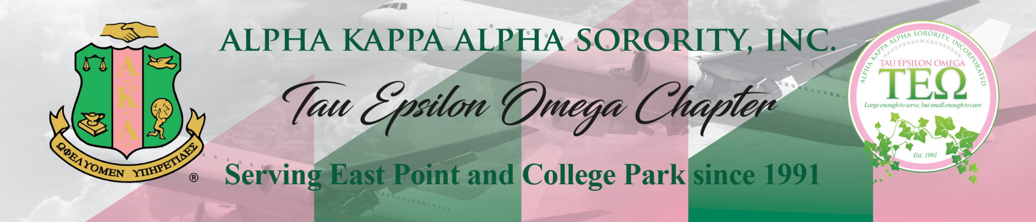
AKA Connection and Social Action Committee Meeting Agenda
Thursday, January 5, 2023, at 6:00 PM
Meeting ID: 995 263 7222
Passcode: pinkivy
https://us02web.zoom.us/j/9952637222?pwd=aldZa0t2a0ExTEdZUDhlZWRTeWlEQT09

Summary: Article I, Section 15, (i) of the Constitution and Bylaws provides that: the Connection Committee “shall consist of a chairman and a representative from each region. The Committee shall identify and study national and international issues which impact quality of life, design strategies for communication with the membership regarding issues, and mobilize the membership for action to formulate and recommend position statements to the Supreme Basileus and/or the Directorate.
- Call to Order & Prayer
- 2023 GA Legislative Session
- MLK Day Social Activities
- 2023 GA AKA Day at the Capitol
- Voter Registration Drive @ Greenbriar Mall Update
- Voter Empowerment Activities @ the Gateway Center Update
Upcoming Meetings & Events
Date & Time | Subject | Location Information
February 19-20, 2023 | Georgia AKA Day at the Capitol | In person at the Capitol & Virtual via Zoom

Contact Information:
Soror Catrice Windley
2022 AKA Connection & Social Action Chairman
678-206-4179/catricewindley@gmail.com

